*Florida International University*

*School of Computing and Information Sciences*

CIS 4911 - Senior Capstone Project

Software Engineering Focus

Feature Document

User Story # 732

**Team Member:**

Garrett Lemieux

**Product Owner(s)**:

Francisco Ortega

**Mentor(s)**:

Francisco Ortega

**Instructor**: Masoud Sadjadi

**User Story – Compressed Brush Buttons**

* As a User I would like to have an organized and intuitive user interface with minimal buttons in order to allow easy interactions with application.
* **Acceptance Criteria**:
  1. Buttons must be compressed to allow full functionality with minimal number of buttons.
  2. Buttons must be intuitive to use.

**Use Case: User Changes Draw Setting with Brush Button**

User changes draw setting using brush button which allows for an organized and intuitive user interface with minimal number of buttons.

* Details:
* Actor:
  + User
* Pre-conditions:
  + TouchPoints app is running.
  + Acer multi-touch device connected.
* Description:
  + Use case begins when User decides to change the current drawing state of the application.
  + User presses brush button.
  + User has option to change line size, change alpha coloring, or turn on filled shapes.
  + Use case ends when user has desired drawing state.
* Post-conditions:
  + Draw setting are set to user’s desired draw state.
* Decision Support:
  + Frequency: High, User needs to be able to change the draw setting with ease and have an organized and intuitive interface.
  + Criticality: High, Main user interface when multi touch is connected.
  + Risk: Low
* Usability:
  + User needs to know location of buttons and the functionality of each button.
* Reliability
  + High
* Performance
  + Performance High
  + Failure Low
* Supportability
  + TouchPointsApp
  + Multi-touch Device
* Modification History:
  + Owner: Garrett Lemieux
  + Initiation Date 04/19/2016
  + Date last Modified: 05/2/2016

**Use Case Diagram**

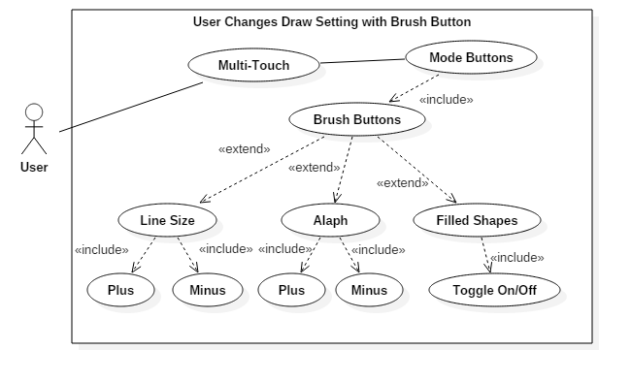

**Sequence Diagram**

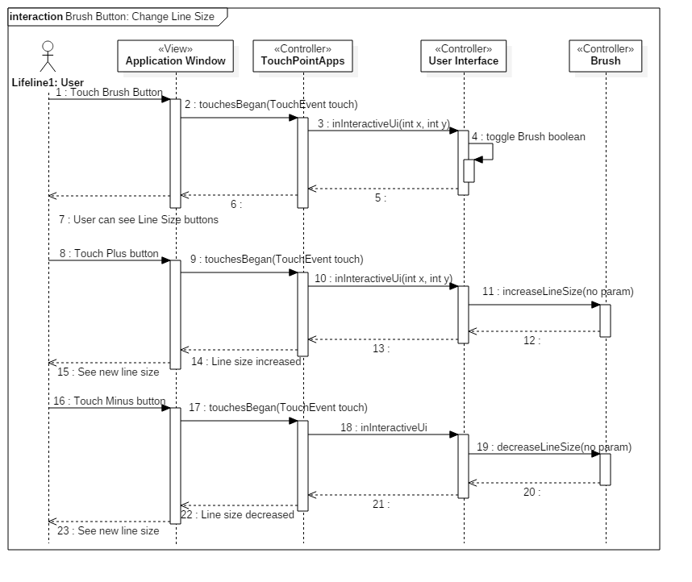

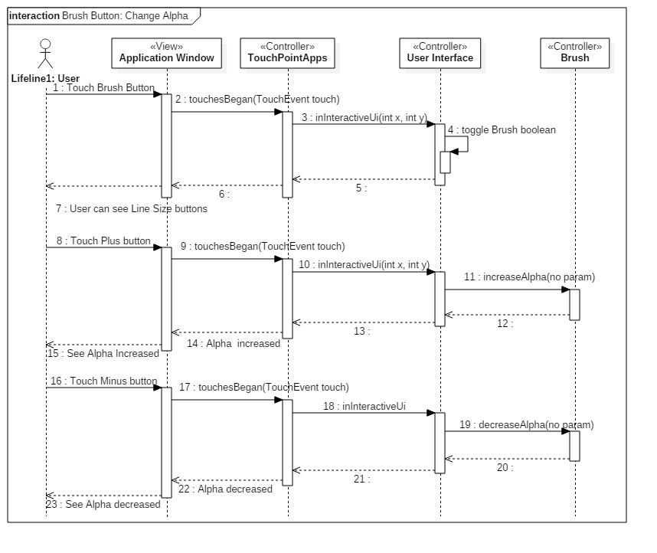

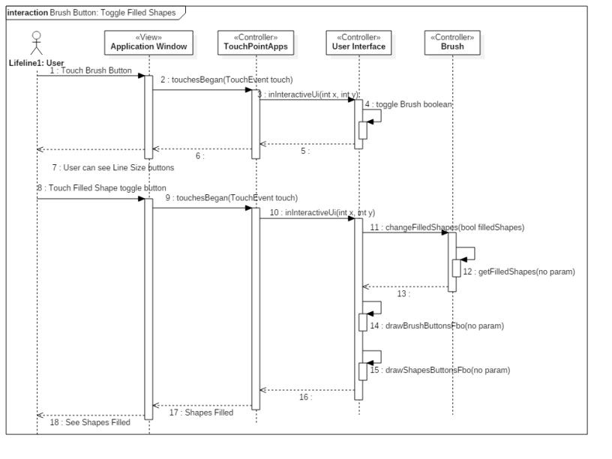

**Class Diagram**

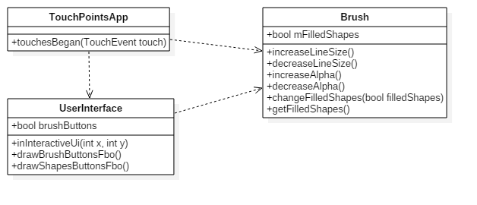

**Unit Test**

* Sunny Day Test:
  + Test Case  - User Increase Line or Shape Size
    - Test Purpose: To determine if the brush button works properly when a person wants to increase the line or shape size.
    - Test Procedure: User draws one line. He or she then presses the brush button. User presses plus button next to line size and draws a second line. He or she then presses plus button again and draws a third line.
    - Expected Results: User should see a line drawn that is the default line size. After brush button is pressed three more buttons should appear underneath the brush button. After second line is drawn user should see a line bigger than the first. After third line is drawn user should see a line bigger than the first and second.
  + Test Case  - User Decrease Line or Shape Size
    - Test Purpose: To determine if the brush button works properly when a person wants to decrease the line or shape size.
    - Test Procedure: User presses the brush button. User presses plus button three times in a row and draws a line. User then presses minus and draws a second line. He or she then presses minus button again and draws a third line.
    - Expected Results: After brush button is pressed three more buttons should appear underneath the brush button. After first line drawn user should see a line drawn that is three sizes bigger than the default line size. After second line is drawn user should see a line smaller than the first. After third line is drawn user should see a line smaller than the first and second.
  + Test Case  - User Increase Alpha of Line or Shape Size
    - Test Purpose: To determine if the brush button works properly when a person wants to increase alpha of line or shape size.
    - Test Procedure: User presses the brush button. User presses minus button next to alpha button three times in a row and draws a line. User then presses plus button and draws a second line. He or she then presses plus button again and draws a third line.
    - Expected Results: After brush button is pressed three more buttons should appear underneath the brush button. After first line drawn user should see a line that is less opaque than the default line or shape. After second line is drawn user should see more opaque line or shape than the first. After third line is drawn user should see a more opaque than the first and second.
  + Test Case  - User Decrease Alpha of Line or Shape Size
    - Test Purpose: To determine if the brush button works properly when a person wants to decrease the alpha of line or shape size.
    - Test Procedure: User draws one line. He or she then presses the brush button. User presses minus button next to alpha line size and draws a second line. He or she then presses minus button again and draws a third line.
    - Expected Results: User should see a line drawn that is the default alpha setting for line or shape. After brush button is pressed three more buttons should appear underneath the brush button. After second line is drawn user should see a less opaque line or shape than the first. After third line is drawn user should see a less opaque line or shape than the first and second.
  + Test Case  - User Turns on Filled Shapes
    - Test Purpose: To determine if the brush button works properly when a person wants to use filled shapes.
    - Test Procedure: User chooses a circle shape. He or she then presses the brush button. User presses filled shape button and draws a circle.
    - Expected Results: User should see a drawn circle that is not filled in. After brush button is pressed three more buttons should appear underneath brush button. Filled shape buttons should be green indicating filled shapes is turned on. Second circle should be on canvas that is filled in.
  + Test Case  - User Turns off Filled Shapes
    - Test Purpose: To determine if the brush button works properly when a person wants to turn filled shapes off.
    - Test Procedure: User chooses a circle shape with filled shapes turned on. He or she draws a circle and then presses the brush button. User presses filled shape button, which is currently green, and draws a circle.
    - Expected Results: User should see a drawn circle that is filled in. After brush button is pressed three more buttons should appear underneath brush button. Filled shape buttons should be black indicating filled shapes is turned off. Second circle should be on canvas that is not filled in.
* Rainy Day Test:
  + Test Case  - User Accidently Presses Box Labeled Line Size
    - Test Purpose: To determine if expected result will occur if user accidently presses Line Size box instead of plus or minus buttons.
    - Test Procedure: User draws line. User then presses brush button and then presses box that has line size label inside of it. He or she then draws a second line.
    - Expected Results: First line drawn should be a line with default size. The second line should be the same size as the first. If the second line is a different size then the first test failed.
  + Test Case  - User Accidently Presses Box Labeled Alpha
    - Test Purpose: To determine if expected result will occur if user accidently presses Alpha labeled box instead of plus or minus buttons.
    - Test Procedure: User draws line. User then presses brush button and then presses box that has Alpha label inside of it. He or she then draws a second line.
    - Expected Results: First line drawn should be alpha default value and completely opaque. The second line should also be completely opaque and default value for alpha. If the second line is less opaque then first, test failed.
  + Test Case  - User Accidently Presses Filled Shape Labeled Box
    - Test Purpose: To determine if expected result will occur if user accidently presses Filled Shape labeled box instead of button.
    - Test Procedure: User draws a none filled circle. User then presses brush button and then presses box that has filled shape label inside of it. He or she then draws a second circle.
    - Expected Results: First circle drawn should be a none filled circle. The circle drawn should also be a none filled circle. If circle filled then it failed.
  + Test Case  - User Accidently Presses Outside Boundary of Alpha, Line Size, and Filled Shapes Buttons
    - Test Purpose: To determine if expected result will occur if user accidently presses just outside of alpha, line size, or filled shapes buttons.
    - Test Procedure: User draws a none filled circle. User then presses brush button. He or she then proceeds to press all along the boundaries of the buttons specified above.
    - Expected Results: First circle drawn should be default size, fully opaque and none filled. The second circle should be the same default size, same opaqueness, and none filled. If any of these three settings have changed test failed.

**Integration Testing**

* All devices were plugged in and application was started. Line size was increased and drawn using all devices with drawing capabilities. Line size was decreased and drawn using all devices with drawing capabilities.
* All devices were plugged in and application was started. For each shape the filled button was activated and shape was drawn using all devices. Then filled shape button was deactivated and shape was drawn using all devices.
* All devices were plugged in and application was started. Alpha was decreased and lines drawn with all devices. Alpha was increased and lines drawn with all devices.
* After integrating brush buttons into application all previous functionality was maintained and functioning correctly.

**User Guide**

* When using Acer multi-touch device a user interface is provided in the left hand corner of the canvas. Each button represents different functionality. The buttons can be seen in the picture below.

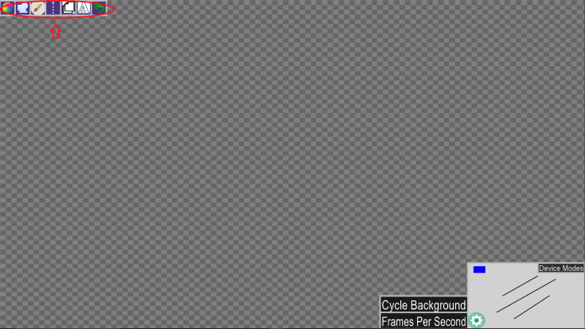

* Each button is represented by a different icon.
* The first button has a circle icon with different colors in the circle and represents the current color setting. Button can be used to choose new color.
* The second button changes the current shape setting. Shapes are automatically set to none filled at start of program. The second button opens up to different shape buttons and the last button represents and eraser button that when activated user can use his or her finger as an eraser.
* The third button is the brush button. This button will be talked about in more detail later in this document.
* The fourth button is the symmetry button that toggles symmetry mode on and off.
* The fifth button allows for up to three different layers to be used and alpha to be altered.
* The sixth button Toggles keyboard on and off.
* The last button is an undo button to remove any mistakes made by user.
* Now the brush button will be explained in more detail. The brush button is by the arrow in the picture below.

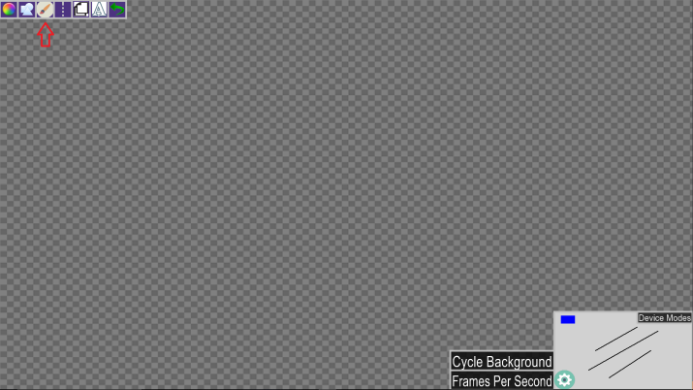

* When the brush button is pressed three more buttons are enabled and allow the user to choose further functionality that will alter the current draw setting.
  + The three buttons will appear below the brush button as shown below

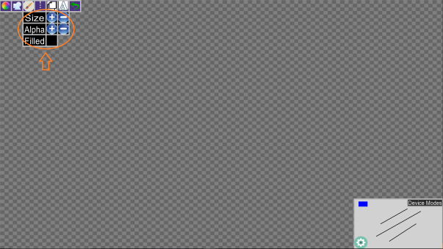

* + The first button represents line size that can be increase by pressing the plus button or decreased by pressing the minus button.

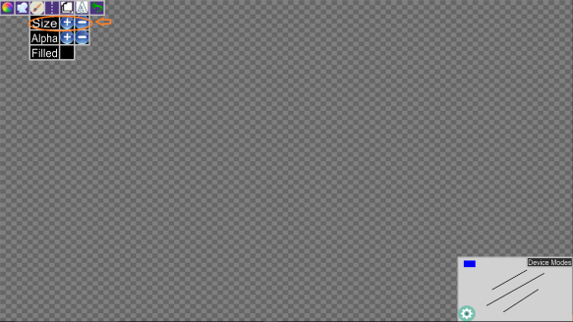

* + The second button represents the alpha setting for the current line or shape. The alpha of a line or shape is the level of opaqueness. The default opaqueness is set to 100 percent at start of application. A user can decrease opaqueness by pressing minus but or increase opaqueness by pressing plus button.

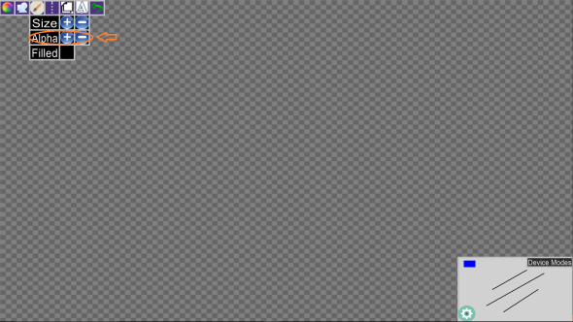

* + The third button is a filled shapes button. It does not have a plus or minus like the other two buttons. Instead a button is directly to the right of the filled shapes button and is black when filled shapes is off and green when filled shapes is on. By pressing the box the user turns on and off filled shapes. This can be seen in the photos below.
    - Filled Shape OFF

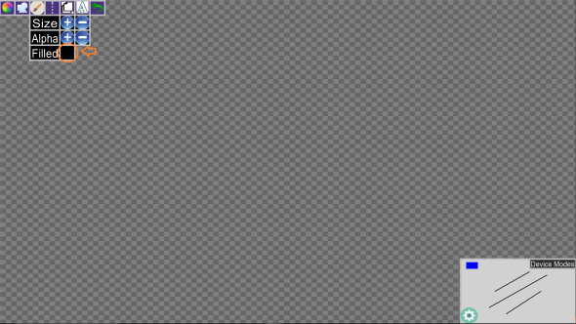

* + - Filled Shape On

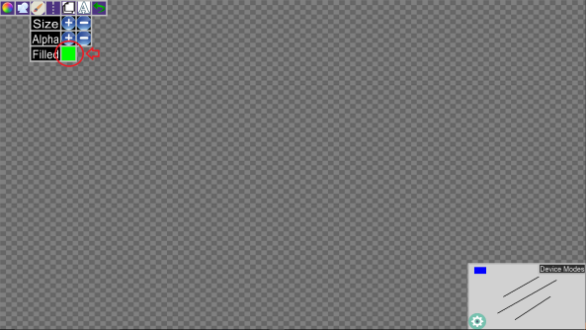

* The brush button was provided to user to allow for a compact organized user interface for the multi-touch device.

**Glossary**

* Opaque - not able to be seen through; not transparent. (Use this in reference to a line or shapes opaqueness when drawn onto the canvas)